MGMS – Create Notification

Detailed Design Document

Ver. 1.4

Version History
Date | Description
20-Nov-2010 | First draft

Table of Contents

Version History 2
1 Introduction 3
2 New Notification 4
3 Associated tables 5
4 Data Dictionary 6

Introduction

This document provides the detailed design specifications for the Multisite Grant Management System project.

This is not a project plan nor does it detail the source code. It is a guide for system architecture and development, not for phasing, timelines or deliverables.

Finally, this is a ‘living document’ and the specification will change, continuously, as the project proceeds. More details will be added and the existing information edited as the requirements, architecture and design evolve in the course of the project.

New Notification

Screen & Control Description

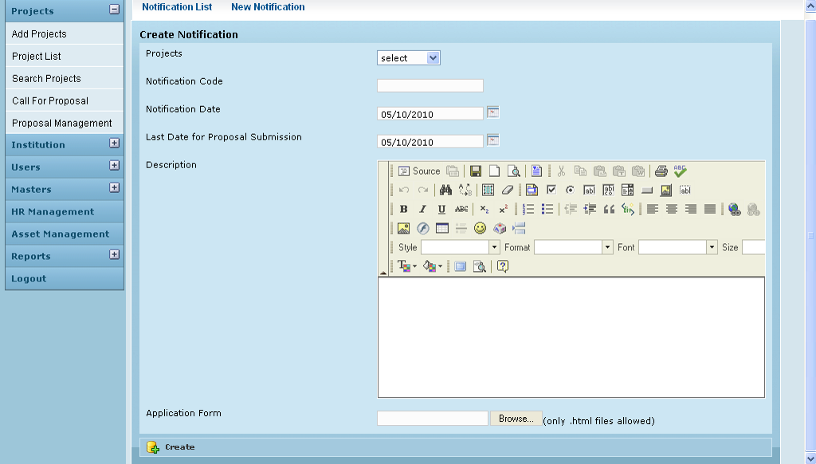

Field /Label | Input-Control | Data Type | Remarks
Notification List | Link
New Notification | Link
Create Notification
Projects | Listbox | varchar(255) | projects>code
Notification Code | Textbox | varchar(255) | notification>notification_code
Notification Date | Calendar | datetime | notification>notification_date
Last Date for Proposal Submission | Calendar | datetime | notification> proposal_submission_last_date
Description | Notepad
Application form | Textbox – auto populated |  | where? Any other details?  For uploading the application form
 | “Browse” - button
 | (only .html files allowed) - label
Create | Button

Upload Attachments

Screen & Control Description

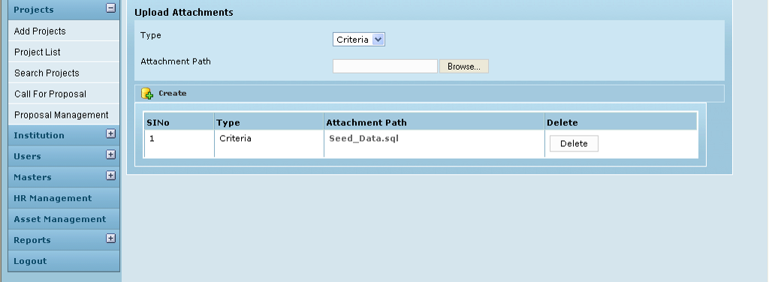

Field /Label | Input-Control | Data Type | Remarks
Upload Attachments
Type | Listbox
Attachment Path | “Browse” button
 | Textbox – auto populated
Create | Button
SlNo | Auto populated
Type | Auto populated
Attachment Path | Auto populated
Delete | “Delete” - button

Associated tables

Data Dictionary

